**Lab#1**

**AIM :: Introduction to HTML**

**Final Outcome:**

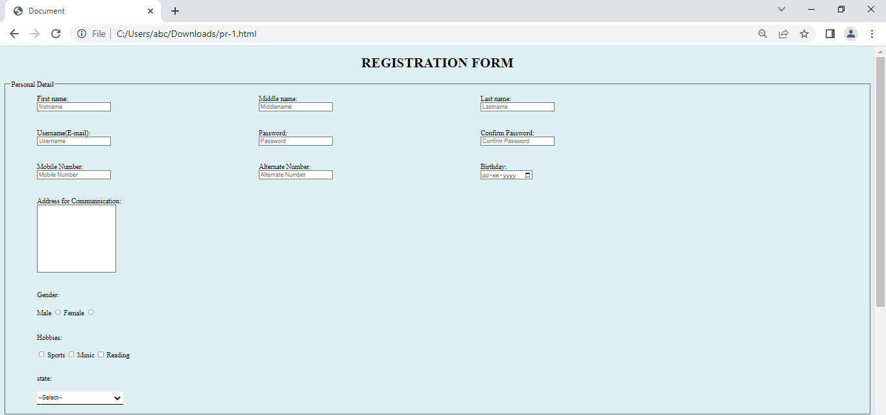

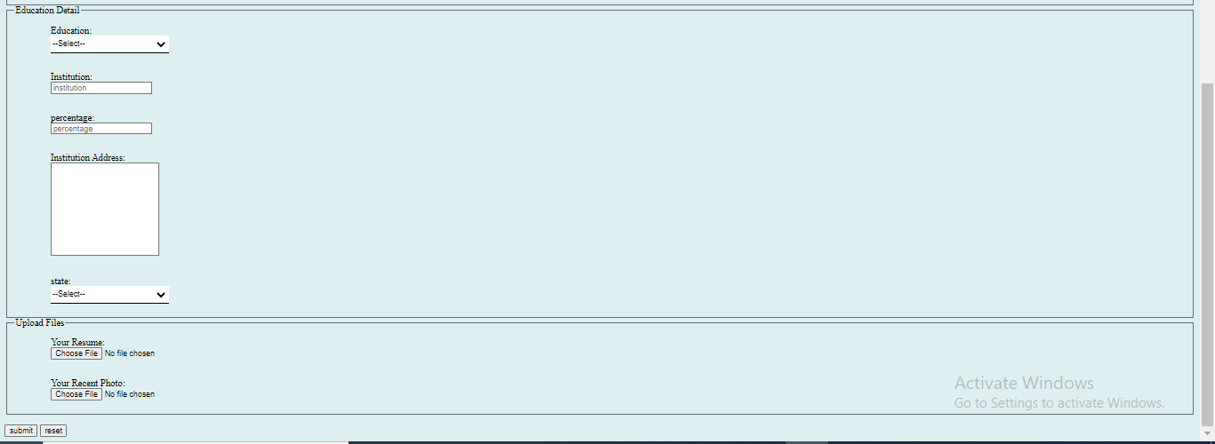

**Code Snippet:**

**HTML file:**

<!DOCTYPE html>

<html lang="en">

<head>

<meta charset="UTF-8">

<meta http-equiv="X-UA-Compatible" content="IE=edge">

<meta name="viewport" content="width=, initial-scale=1.0">

<title>Document</title>

<link rel = "stylesheet" href = "form_css.css">

</head>

<body>

<h1 align="center">REGISTRATION FORM</h1>

<form>

<fieldset>

<legend>Personal Detail</legend>

<table>

<tr>

<td style="padding-right: 280px; padding-bottom: 30px;">

<label for="fname">First name:</label><br>

<input type="text" id="fname" name="fname" placeholder="firstname">

</td>

<td style="padding-right: 280px; padding-bottom: 30px;">

<label for="mname">Middle name:</label><br>

<input type="text" id="Mname" name="Mname" placeholder="Middlename">

</td>

<td style="padding-right: 280px; padding-bottom: 30px;">

<label for="lname">Last name:</label><br>

<input type="text" id="Lname" name="Lname" placeholder="Lastname">

</td>

</tr>

<tr>

<td style="padding-right: 280px; padding-bottom: 30px;">

<label for="uname">Username(E-mail):</label><br>

<input type="text" id="Uname" name="Uname" placeholder="Username">

</td>

<td style="padding-right: 280px; padding-bottom: 30px;">

<label for="pass">Password:</label><br>

<input type="password" id="pass" name="pass" placeholder="Password">

</td>

<td style="padding-right: 280px; padding-bottom: 30px;">

<label for="cpass">Confirm Password:</label><br>

<input type="password" id="cpass" name="cpass" placeholder="Confirm Password">

</td>

</tr>

<tr>

<td style="padding-right: 280px; padding-bottom: 30px;">

<label for="Mnumber">Mobile Number:</label><br>

<input type="number" id="Mnumber" name="Mnumber" placeholder="Mobile Number">

</td>

<td style="padding-right: 280px; padding-bottom: 30px;">

<label for="Anumber">Alternate Number:</label><br>

<input type="Anumber" id="Anumber" name="Anumber" placeholder="Alternate Number">

</td>

<td style="padding-right: 280px; padding-bottom: 30px;">

<label for="birthday">Birthday:</label><br>

<input type="date" id="birthday" name="birthday" placeholder="Date of Birth">

</td>

</tr>

<tr>

<td style="padding-bottom: 30px;">

<label for="Address">Address for Communnication:</label><br>

<textarea name="Address" id="Address" cols="20" rows="10"></textarea>

</td>

</tr>

<tr>

<td>

Gender:

</td>

</tr>

<tr>

<td style="padding-bottom: 30px;">

<label for="male">Male</label>

<input type="radio" id="male" name="male" value="Male">

<label for="male">Female</label>

<input type="radio" id="fmale" name="fmale" value="Female">

</td>

</tr>

<tr>

<td>

Hobbies:

</td>

</tr>

<tr >

<td >

<input type="checkbox" id="h1" name="h1" value="Sport">

<label for="h1"> Sports</label>

<input type="checkbox" id="h2" name="h2" value="Music">

<label for="h2"> Music</label>

<input type="checkbox" id="h3" name="h3" value="Reading">

<label for="h3"> Reading</label><br><br>

</td>

</tr>

<tr>

<td>

state:

</td>

</tr>

<tr>

<td>

<select name="state" id="state" >

<option value="">--Select--</option>

<option value="Gujarat">Gujarat</option>

<option value="Punjab">Punjab</option>

<option value="Delhi">Delhi</option>

<option value="Madhya Pradesh"> Madhya Pradesh </option>

<option value="">Mumbai</option>

</select>

</td>

</tr>

</table>

</fieldset>

<fieldset>

<legend>Education Detail</legend>

<table>

<tr>

<td style="padding-bottom: 20px;">

Education: <br>

<select name="ed" id="ed">

<option value="">--Select--</option>

</select>

</td>

</tr>

<tr>

<td style="padding-bottom: 20px;">

<label for="institution">Institution:</label><br>

<input type="text" id="institution" name="institution" placeholder="institution">

</td>

</tr>

<tr>

<td style="padding-bottom: 20px;" >

<label for="percentage">percentage:</label><br>

<input type="number" id="percentage" name="percentage" placeholder="percentage">

</td>

</tr>

<tr>

<td style="padding-bottom: 20px;">

<label for="IAddress">Institution Address:</label><br>

<textarea name="IAddress" id="IAddress" cols="20" rows="10"></textarea>

</td>

</tr>

<td>

state: <br>

<select name="state" id="state">

<option value="">--Select--</option>

<option value="Gujarat">Gujarat</option>

<option value="Punjab">Punjab</option>

<option value="Delhi">Delhi</option>

<option value="Madhya Pradesh"> Madhya Pradesh </option>

</select>

</td>

</table>

</fieldset>

<fieldset>

<legend>Upload Files</legend>

<table>

<tr>

<td style="padding-bottom: 20px;">

<label for="ur" >Your Resume:</label><br>

<input type="file" name="upload resume" id="ur">

</td>

</tr>

<tr>

<td>

<label for="urp" >Your Recent Photo:</label><br>

<input type="file" name="upload recent photo" id="urp">

</td>

</tr>

</table>

</fieldset> <br>

<input type="Submit" value="submit">

<input type="Reset" value="reset">

</form>

</body>

</html>

**External css file:**

body{

background-color: rgb(222, 239, 241);

}

td{

padding: 10px 60px 10px 60px;

}

.text,select{

border: none;

border-bottom: 2px solid black;

width: 200px;

height: 30px;

}

textarea{

resize:none;

}

.menu{

width: auto;

height: auto;

}